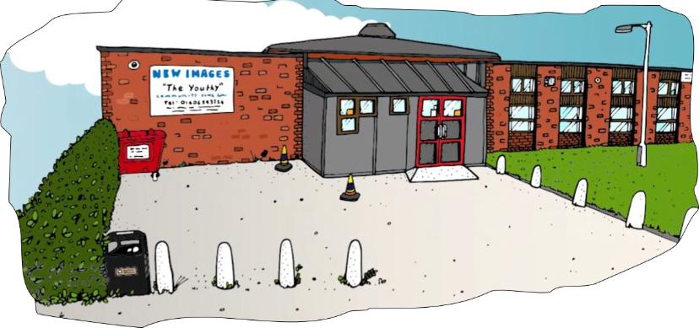

Sessional Play & Youth Workers
Looking for a fun, varied role which provides the ultimate job satisfaction?
We’re searching for friendly and enthusiastic people to join our team as Play and Youth Workers!
Are you energetic and enthusiastic individual who is dedicated to delivering inclusive fun for young people, that enjoys working in a busy, social environment?
This role could be perfect for you!
Hours – Weekends/Evening and during School Holidays
Rate of Pay – To be confirmed
As a Youth Sessional Worker, you will be responsible for planning, delivering, and evaluating the activities, as well as building positive relationships with the young people. You will also need to follow the policies and procedures of the organisation and ensure the safety and well-being of everyone involved.
New Images Youth & community Centre (WYCF) is an independent charity, providing a safe and inspiring place for all young people. Open 7 days a week including school holidays, our vision is for every young person to be supported & empowered to reach their potential.
Join us in making a difference and raising the aspirations of young people in Winsford and in the surrounding area. Safeguarding is paramount, and an enhanced DBS check is required. As an equal opportunity employer, we value individuals regardless of race, colour, religion, sex, sexual orientation, gender identity, national origin, or disability.
We are especially looking for youth workers who would be confident in supporting young people with additional needs including autism, ADHD & behavioural issues.
If you have a passion for working with children and want to make a difference, we will welcome your application.
For an informal chat please contact Debbie Cragg on 01606 659413 or request an application form from laura.jones@wycf.co.uk

Job Description and Specification

Youth Support Worker
Location: New Images Youth & Community centre
Hours: To be discussed mainly teatime, evenings, and school holidays
Rate of pay: £11.50 per hour
Responsible to Senior Youth Worker and member of management team.
Purpose of post
To join a team of existing and new workers to deliver a structured programme of projects and activities that endeavour to meet the needs of young people.
Responsibilities
- To maintain the ethos of the organisation by providing a caring, safe, and supportive environment
- Support the organisation as a whole to implement policies and procedures
- To ensure young people play an active role in the centre activities
- To develop and maintain positive relationships and involvement with the planned programme
- To be part of a team of workers that is able to identify the needs of young people and plan a programme of positive interventions and innovation, that enhances the knowledge, awareness and the personal development of young people
- To follow set procedures and policies set out by Winsford Youth & Community Forum and inform the management team of any personal concerns relating to sessions
- To support young people in evaluating youth work activities and identifying the impact of youth work
- To record young peoples progression in sessional and project recording documentation and support senior staff in providing information for funding reports

