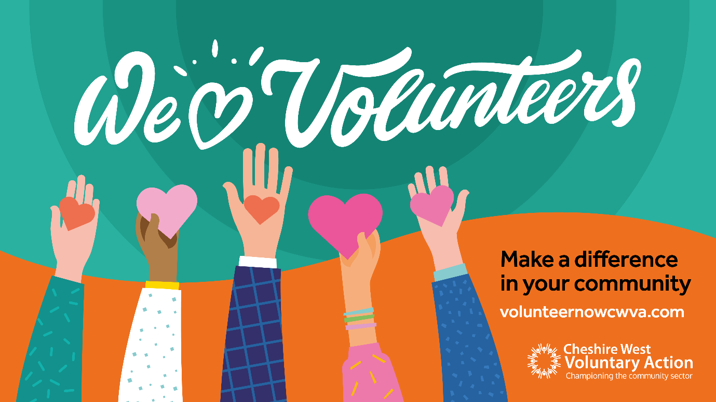
Background
Cheshire West Voluntary Action’s (CWVA) new volunteering platform is completely free for all members to use.
The platform provides plenty of benefits for CWVA members and their staff, such as being able to oversee volunteer recruitment from start to finish, run off useful reports, manage timesheets, communicate directly through the system and much more.
Potential volunteers are also able to visit the platform and easily browse for opportunities by location, organisation, service area and the benefits being offered by organisations. They can pick something that suits them and their interest so you’re getting the right volunteers for your organisation.
For CWVA members, the volunteer recruitment process and how you market it doesn’t need to change, but the platform is a new tool you can use and a place you can direct potential volunteers to apply. With the number of opportunities currently on the platform, it is picking up a lot of traffic.
We’ve put together this communication pack to help you promote the volunteering platform and your opportunities available on there. If you have questions about anything included, please feel free to email: ryan.gould@chesterva.org.uk.

Template for press release
[Insert your organisation name] is using Cheshire West Voluntary Action’s (CWVA) new volunteering platform to showcase its range of opportunities for volunteers so they can make a real difference in their community.
The volunteering platform provides a chance for potential volunteers to easily browse and find an opportunity right for them as they can search by location, organisation, service and much more.
There are a range of benefits people can gain through volunteering, such as learning new skills, making new friends, becoming more employable, making a positive difference in your community and much more.
[Insert your organisation name and description of what you do]
You can apply for the following opportunities through the platform.
- [Insert name of volunteering opportunity]
- [Insert name of volunteering opportunity]
- [Insert name of volunteering opportunity]
[Insert volunteer’s name] has been volunteering at [Insert your organisation name], making a big difference to the services it delivers in the heart of the community.
They said: “[Add quotes from volunteer]
- Apply for volunteering opportunities today

Template for social media posts
Want to make a real difference in your community and learn new skills? [Insert your organisation name] is recruiting volunteers through Cheshire West Voluntary Action’s volunteering platform.
Apply today: https://volunteernowcwva.com

At [Insert your organisation name], we’re currently on the lookout for volunteers to support us with [Add information about your service or project].
Get involved with volunteering: https://volunteernowcwva.com

Join our amazing volunteer workforce. Make new friends, learn new skills and become more employable. Volunteering brings so many benefits.
Apply today: https://volunteernowcwva.com

Volunteering is flexible and you can fit it around any other commitments you may have. At [Insert your organisation name], we have opportunities to suit everyone and you can gain plenty of new skills at the same time.
Get involved with volunteering: https://volunteernowcwva.com

Resources
We’ve put together an A5 flyer that you can use to promote the volunteering platform. This should ideally be printed off and displayed in physical locations rather than online. We also have professionally printed copies you can use.
- Download a copy of the A5 flyer
We’ve also designed a range of social media graphics. These have been produced specifically for different social media platforms.
- Download a graphic for Facebook
- Download a graphic for Twitter
- Download a graphic for Instagram

