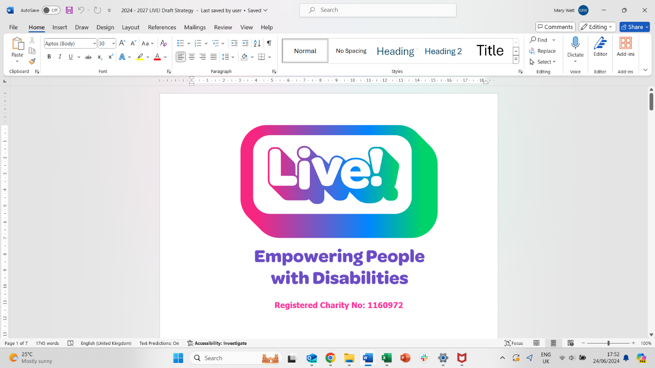
APPLICATION FORM

- You must complete all sections of the Application Form in black ink or electronically
- We will use this form to help us decide on your suitability for the post
- Please make sure it is accurate and complete
- CVs will not be accepted in isolation, but in conjunction with this application form
- Guidance Notes are included to help you complete this form
Position applied for: |  | Closing date:
Where did you first learn of this vacancy?

Personal Details and Contact Details
Title: Surname: Forenames (in full):
Please also provide details of any former names
(if applicable)
Home Address: |  | Daytime Telephone No:
 |  | Evening Telephone No:
 |  | Mobile No:
 |  | National Insurance No:
Post Code: |  | email:
Address history (please include last five years - insert additional lines if necessary)
Address: |  | From / to:
Address: |  | From / to:
Address: |  | From / to:
Entitlement to work in the UK
All applicants will be asked at interview to provide documentary evidence of their right to work in the UK – do you have any restrictions that apply to you?
Yes* ☐ No ☐
*If yes – please give details of any restrictions:

References
Please provide details of two referees who can comment on your suitability for this post. If you do not wish us to contact a referee prior to inteview, then please tick the appropriate box.
Referee 1 (current or most recent employer) ☐ |  | Referee 2 ☐
Name: |  | Name:
Relationship to applicant: |  | Relationship to applicant:
Position: |  | Position:
Employer/University/College Name: |  | Employer/University/College Name:
Address: |  | Address:
Post Code: |  | Post Code:
Telephone No: |  | Telephone No:
E-mail: |  | E-mail:

Current Employment (or last employment if not currently employed)
Employer Name:
Employer Address:
Post Title:
Start date (dd/mm/yyyy): |  |  | End date (dd/mm/yyyy):  (if applicable)
Please give a brief description of current duties, responsibilities and achievements:
Reason for leaving this post:
What is your contractual period of notice? |  | Current Salary:

Previous Employment
(please list all your employment history and add additional rows if necessary.)
Name and address of Employer | Job Title | Start Date  (dd/mm/yyyy) | End Date  (dd/mm/yyyy) | Reason for  Leaving

Gaps in Employment
Please indicate and explain any gaps in employment since first leaving secondary education.
Include specific dates and be sure to account for all gaps, whatever their length.
From:  (mm/yyyy) | To:  (mm/yyyy) | Reason for gap

Education
If the post requires a particular qualification, you will be asked to produce original evidence if successful.
Secondary and Further Education (please list in chronological order and start / finish dates mm/yyyy) | Level | Subjects | Grade/  Result | Year  Obtained  (yyyy)

Additional CPD
Title and brief description of course | Date

Membership of Professional Associations or Statutory Body
Organisation Name | Level of Membership/Role/Registration No. (if applicable) |  |  | Registration Date
Are you subject to any conditions or prohibitions placed on you by any statutory body in the UK. *If Yes – please provide details in a sealed envelope and attach with this form |  | Yes* | ☐ |  | No | ☐

Personal Statement
Please share your reasons for applying for this post
Demonstrate how your skills, abilities, knowledge and experience meet the selection criteria

Additional Information
Are you licensed to drive any of the following? | Private Car | ☐ | Minibus | ☐ | PSV | ☐ | Other (give details)
Please confirm whether this will be your only employment? |  |  |  |  |  |  |  | Yes | ☐ | No* |  | ☐
* If no, provide details including days and hours worked and whether full- or part-time:
Have you been the subject of a formal disciplinary sanction or are you in the process of ongoing disciplinary proceedings in your current employment? |  |  |  |  |  |  |  | Yes * | ☐ |  | No | ☐
Have you been dismissed from any previous employment? |  |  |  |  |  |  |  | Yes * | ☐ |  | No | ☐
* If yes, please indicate which employment and specify the reasons for your disciplinary / dismissal (use a separate sheet if necessary):

If you are short-listed for interview the panel will discuss this with you and your current or previous employers.
If you are related to anyone in this organisation please provide details:

- Enhanced DBS Check:

All posts are subject to an Enhanced DBS check so that any criminal background (including “spent” convictions, bind-over orders or cautions) is disclosed to the organisation. We cannot employ someone to this post without this check. If you are successful in applying for this post we will ask the DBS for a Disclosure. The position for which you are applying involves contact with vulnerable groups. It is exempt from the Rehabilitation of Offenders Act 1974 and all subsequent amendments (England and Wales). For this position you are not entitled to withhold information about police cautions, bind-overs, or any criminal convictions that would otherwise have been considered “spent” under the Act.

B) Safeguarding Declaration:
I declare that the information I have given on this form is complete and accurate and that:
- I am not barred or disqualified from working with vulnerable groups, children or young people
- I am not subject to any sanctions or conditions on my employment imposed by the Independent Safeguarding Authority, Secretary of State or other regulatory body. .

Signed: Print Name:

dd/mm/yyyy

Date:

C) General Declaration
I understand that to knowingly give false information or to leave out any relevant information could result in:
- the withdrawal of any offer of appointment, or
- my dismissal at any time in the future, and possible criminal prosecution

Signed: Print Name:

dd/mm/yyyy

Date:

Availability:
Are there any dates when you are not available for interview?
PLEASE RETURN THIS FORM TO: admin@livecheshire.org.uk

