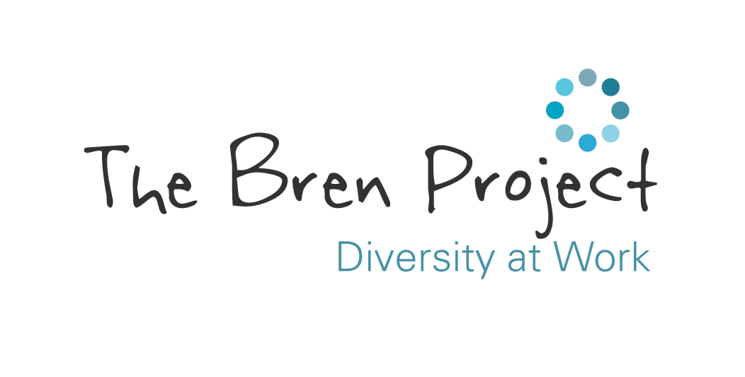
JOB DESCRIPTION

TITLE: Bren Brews - Café Supervisor (1 year fixed initially)

SALARY: £21,216 pa (£13.60 ph), plus private healthcare insurance and generous pension scheme.

HOURS: 30 hours per week, job share considered.

BASED: Hoole URC, with the possibility of other local locations in the future.

RESPONSIBLE TO: Café Project Manager / Charity Manager

A really exciting opportunity to join a growing charity as we launch our exciting new hospitality enterprise for our beneficiaries!

DUTIES AND RESPONSIBILITIES

Key purpose: To support the Café Project Manager in running our new café provision - cultivating a warm, friendly and inclusive environment for staff, volunteers and beneficiaries.

- To work with the Café Project Manager to oversee compliance with statutory regulations relating to safe systems of work, allergens management, health & safety, food hygiene, cleanliness, fire and COSHH.

- To develop and maintain positive working relationships with all Bren staff, volunteers, beneficiaries and café customers.

- To support and monitor beneficiaries whilst in the workplace and line manage volunteers.

- To ensure that drinks and meals are prepared to a high standard, compliant with food safety standards.

- To ensure that all food and beverages are served with due care and attention and to be accountable for all customer dietary requirements: for example, nut or wheat allergies.

- To adhere to internal policies, procedures and safe systems of work to comply with statutory regulations.

- To monitor the serving and storage of foods, keeping records as required and taking appropriate action where necessary to ensure that we comply with HACCP procedures.

- To implement and periodically review all cleaning schedules and opening, close down and security procedures to meet agreed standards

- To deliver inductions and training of new volunteers and beneficiaries.

- To adhere to risk assessments relating to café operations and beneficiary work placements.

- To undertake regular liaison with the Café Project Manager, providing appropriate information and feedback.

- To contribute to project, partnership and team meetings as necessary.

- To promote the charity in a positive and professional manner, including attending events with our partners and utilising our social media channels.

- The post holder may be required from time to time to undertake other duties, not specifically mentioned in this job description, commensurate with the role.

Andrew Ashford
Charity Manager
August 2025

