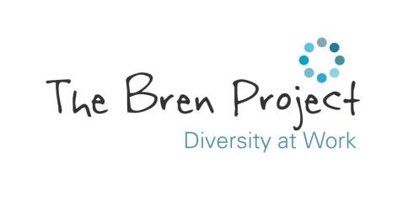

**Café Manager - Person Specification**

*(Key: A = Application Form, I = Interview, R = References)*

**Essential:**

***Experience:***

* Minimum of 1 year’s experience of working with people with learning disabilities and/or autism. *(A,I,R)*
* Minimum of 1 year’s management experience within a training or hospitality setting. *(A,I,R)*
* Food Hygiene qualification or willingness to work towards. *(A)*

***Knowledge and Understanding:***

* Working knowledge and understanding of statutory regulations relating to safe systems of work, allergens management, health & safety, food hygiene, cleanliness, fire and COSHH. *(A,I,R)*
* Awareness of disability and the barriers faced by people with disabilities accessing the workplace. *(A,I)*

***Teamwork:***

* Strong interpersonal skills and the ability to positively contribute as a team player. *(A,I,R)*
* Be able and willing to take and offer advice. *(A,I,R)*

***Communication:***

* Experience of communicating with a wide range of people in a multi-agency environment. *(A,I)*

***Integrity:***

* Be fair, respectful, ethical and honest. *(A,I,R)*
* Protect confidential information in accordance with data protection and GDPR guidelines. *(A,I)*
* Committed to supporting diversity and equality of opportunity. *(A,I,R)*

***Problem Solving:***

* Ability to work autonomously, problem solve and approach tasks in a logical manner. *(A,I,R)*
* Willingness to learn, develop and grow, taking responsibility for personal CPD. *(A,I)*

***Skills, Abilities and Competencies:***

* Have the ability to make accurate judgements about our beneficiaries ability, support and development needs. *(A,I,R)*
* Ability to organise and prioritise multiple tasks, ensuring timescales/deadlines are met. *(A,I,R)*
* IT literate – experience of using Microsoft Office and an understanding of how to utilise social media platforms. *(A,I,R)*
* Able to promote our service to all relevant stakeholders. *(A,I)*

***Other:***

* Flexibility - be available for occasional out of hours and weekend working. *(A,I)*
* Enhanced DBS will be required.

**Desirable:**

* Experience of working in a supported employment environment. *(A,I)*
* Flexibility to adapt to various workplace environments. *(A,I)*
* Experience in a training, mentoring or an assessment role. *(A,I)*